Spring Core – Demonstration of Singleton Scope and Prototype Scope
Created another instance of the same class country using the context.
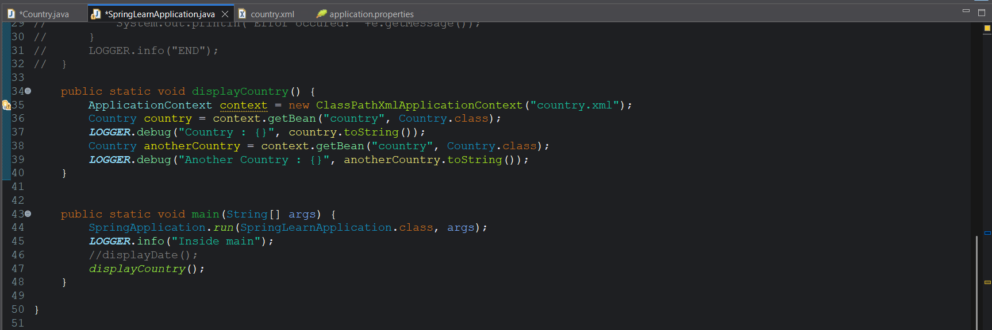
Since by default it is singleton type it is throwing the same object without creating a new object on every call. That’s why we are getting the constructor logger statement only once.
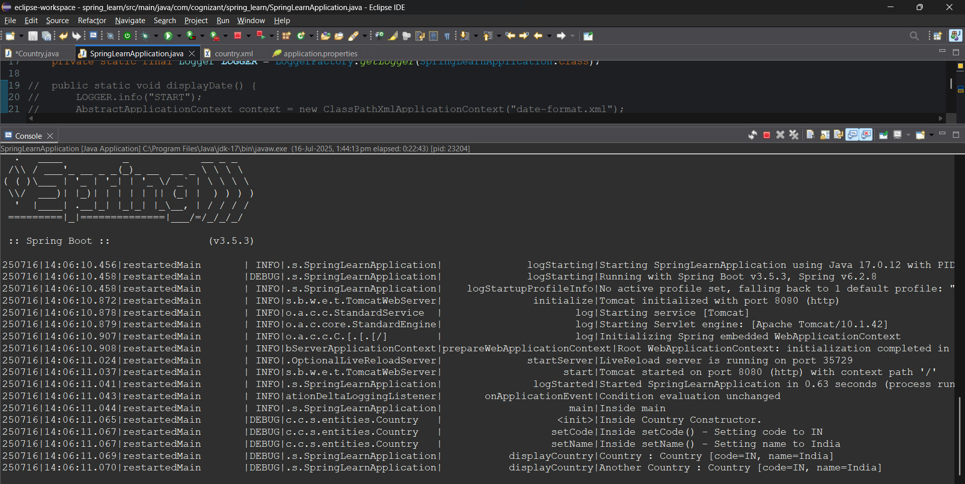
Now to make it to create a new object on every call we need to add another attribute “scope” in the bean configuration and set it to “prototype”
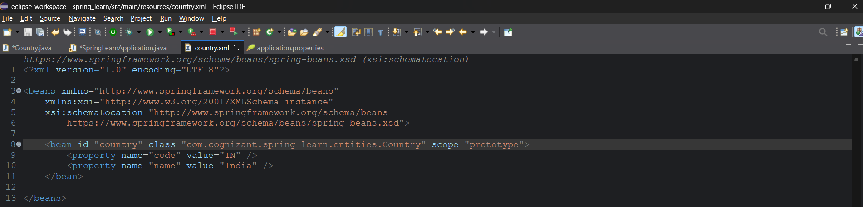
Added scope attribute.
Output:
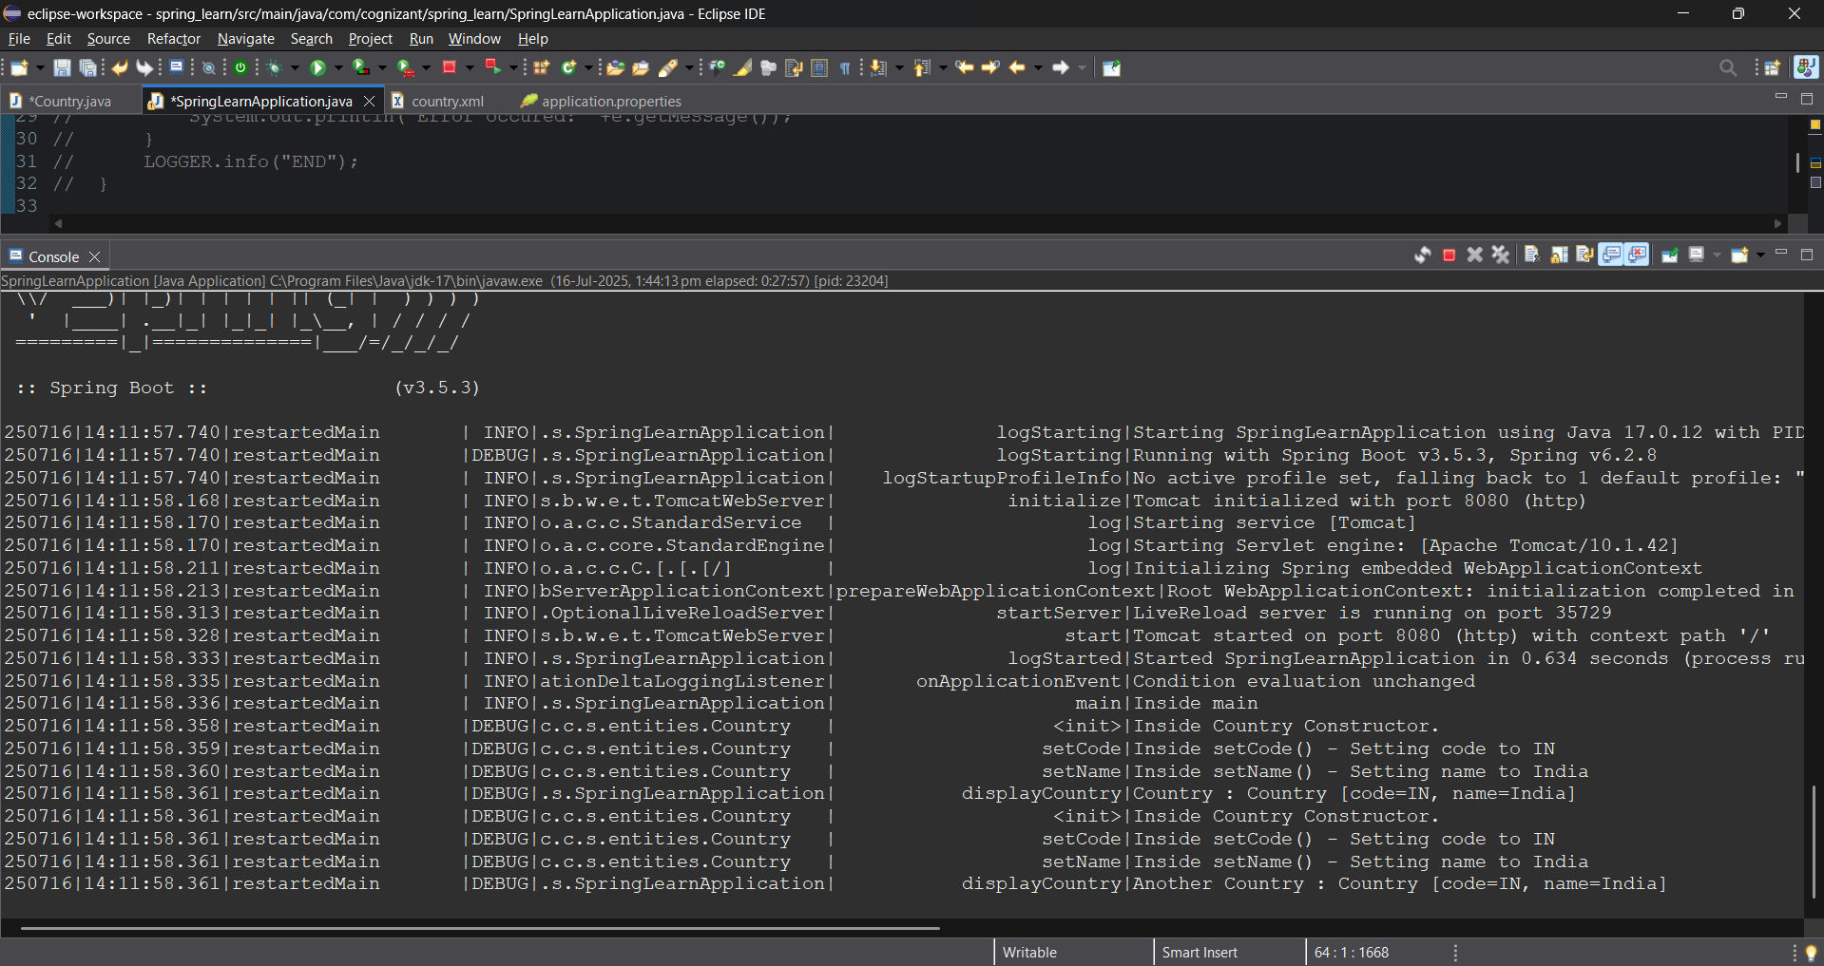
Now we are able to see multiple logs of constructor

